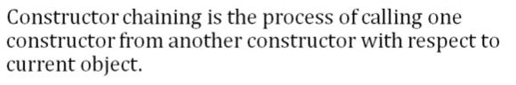

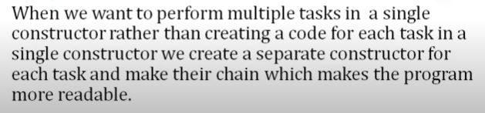

**The this keyword points to a reference of the current class.**

**this can be used to access variables and methods of the current class.**

**this( ) is used to call one constructor from the other of the same class.**

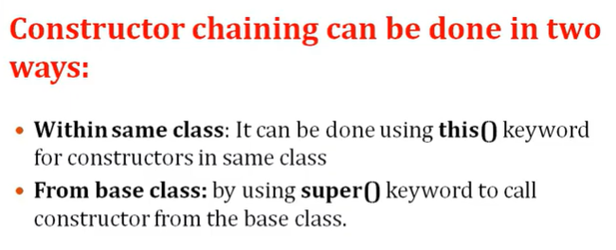

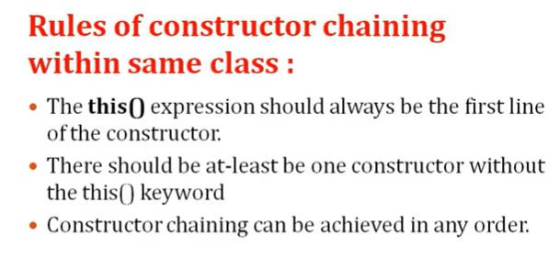

…………………………………………………………………………………………………………………………………………………………

**(i)**



**Constructor Chaining**

**Example 1:**

**Constructor.java**

package pack1;

class Constructor

{

Constructor( )

{

System.out.println("default constructor");

}

Constructor(int a)

{

this( );

System.out.println("single parameter constructor");

}

Constructor(int a, int b)

{

this(b);

System.out.println("two parameter constructor");

this.display( );

}

public void display( )

{

System.out.println("Display method");

}

public static void main(String[ ] args)

{

Constructor obj = new Constructor(10, 20);

}

}

Example 2:

public class ConstructorChain

{

//default constructor

ConstructorChain( )

{

this("Java");

System.out.println("Default constructor called.");

}

//parameterized constructor

ConstructorChain(String str)

{

System.out.println("Parameterized constructor called");

}

//main method

public static void main(String args[ ])

{

//initializes the instance of example class

ConstructorChain cc = new ConstructorChain();

}

}

Output:

Parameterized constructor called

Default constructor called